1. 
2. 
3. Based on your requirement, it is also possible to query the data in IMap using **SQL-Like Language**.
4. Say, you want the ability to search for customers based on their email address.  
   Then we need to create a method **findCustomerByEmail()** on our CustomerService.java.
5. Jatin 🡺 Following just for reference purpose: Graphical user interface, text

   Description automatically generated
6. 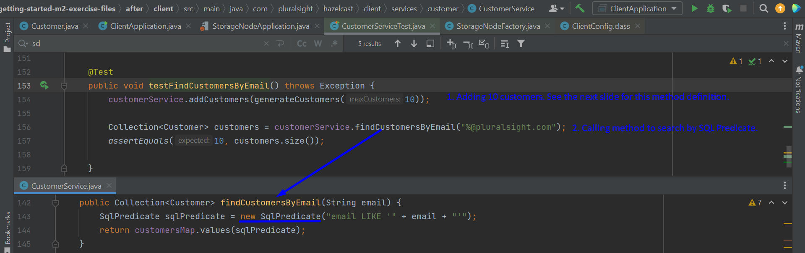  
   Text

   Description automatically generated  
   